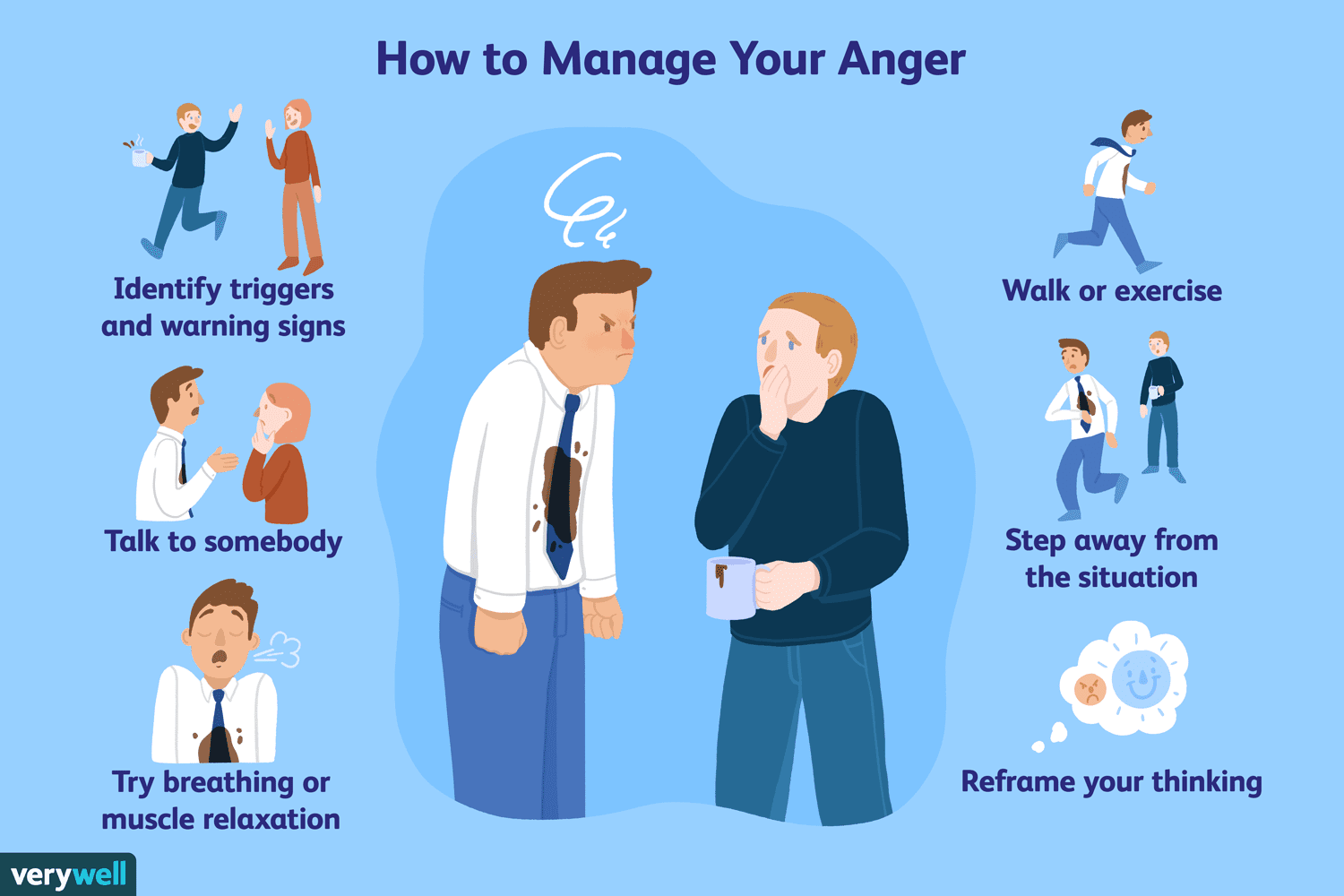

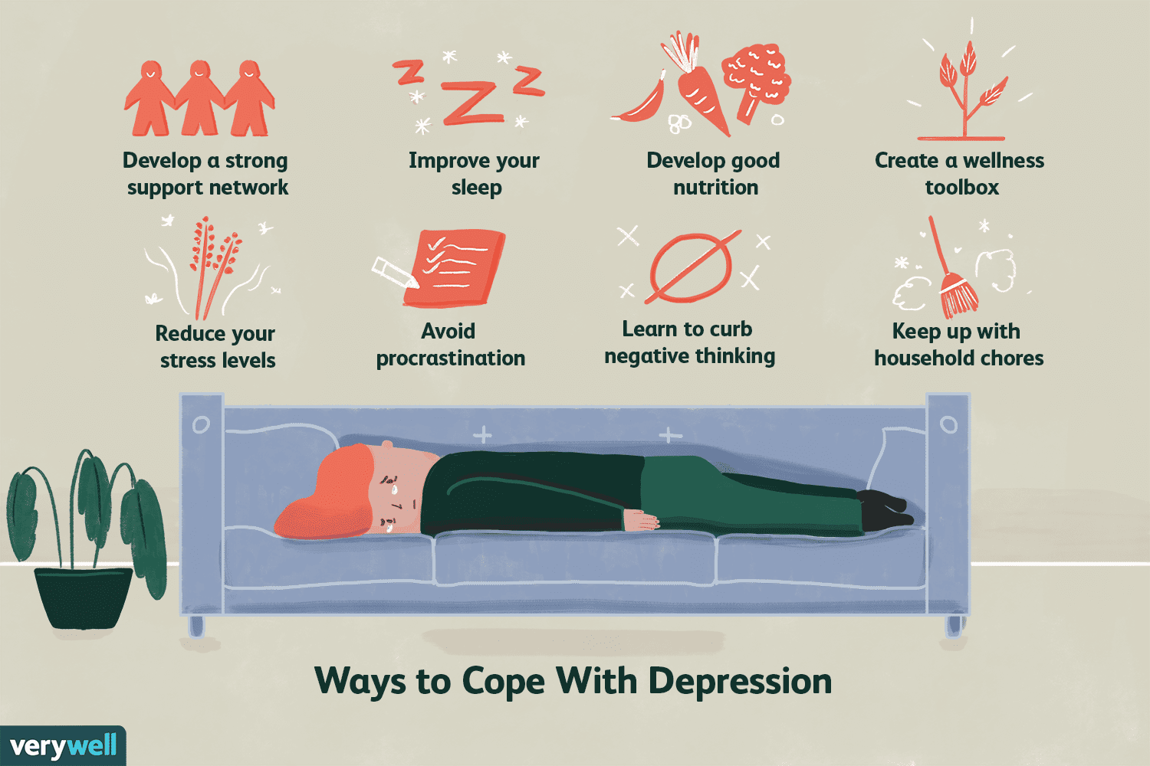

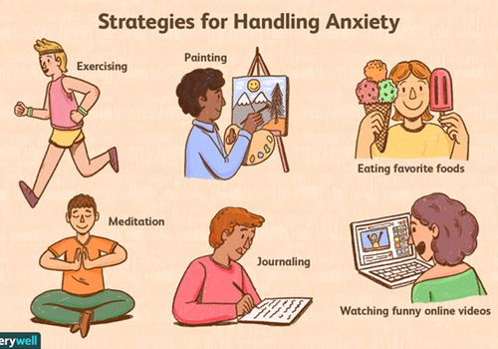

Managing peer pressure

**What strategies can help handle negative peer pressure?**

* Pay attention to how you feel. ...
* Plan ahead. ...
* Talk to the person who is pressuring, let him or her know how it makes you feel and tell the person stop.
* Have a secret code to communicate with parents. ...
* Give an excuse. ...
* Have friends with similar values and beliefs.



